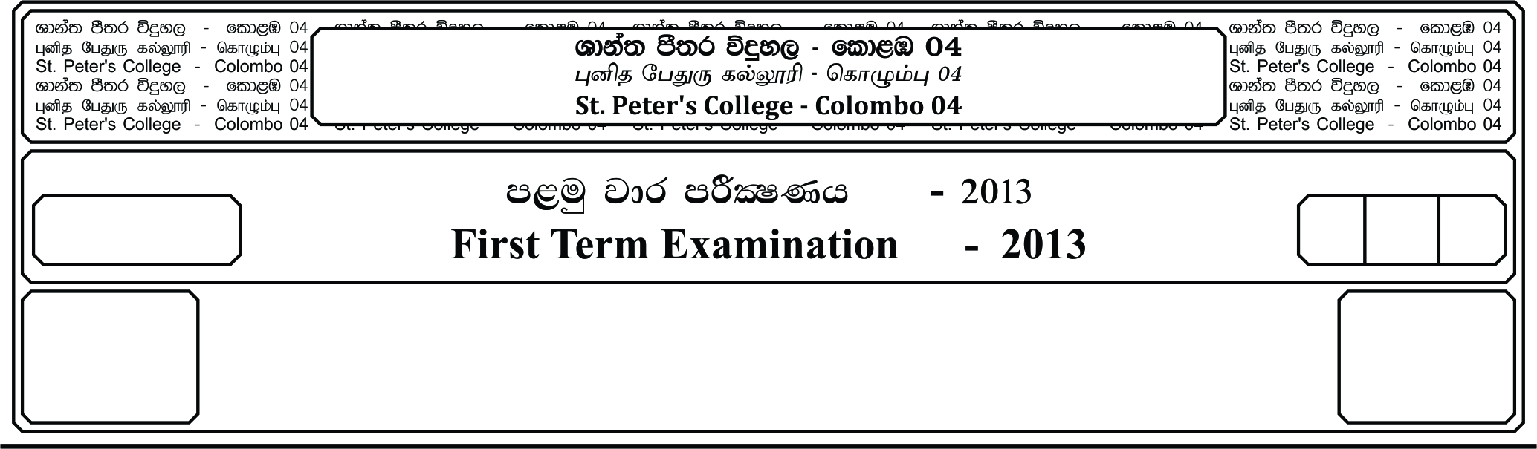

13 fY%aKsh

GRADE 13

21

meh 03

03 Hours

II

**m<uq jdr mÍCIKh - 2024**

**First Term Examination - 2024**

wd¾Ól úoHdj - ¸¸

**ECONOMICS - II**

E

Instructions;

* Answer five questions only, selecting minimum of two questions from **sub-section** and two questions from **sub-section** .

**Sub-Section A**

01. i. Define an economic system and explain the major role of an economic system.

ii. “Problem of production and decision of production is a one of basic economics problems.” Do you agree with this statement? Give reasons.

iii. “Compared to alternative economic systems, free market economic system always maximize social welfare of a society.” Do you agree?

iv. Categories the following resources according to the factors of production.

a). Water treatment plant.

b). A stock of readymade garments.

c). A teak plantation.

d). A fruits planter.

v. You are given the following production possibilities schedule of an economy which produce commodity and

|  |  |
| --- | --- |
| **Commodity** | **Opportunity Cost (intermits of )** |
| 25 | 10 |
| 20 | 8 |
| 15 | 6 |
| 10 | 4 |
| 5 | 2 |
| 0 | _____ |

a). Construct the production possibilities curve.

b). Assume at present nation produces 15 million units of commodity and 10 million units of commodity . Mark the production point on the graph and given your idea.

***(04 marks per each)***

02. i. a). Explain the law of demand with the help of a diagram.

b). Explain the theorical factors that provide the basis for the law of demand.

ii. a). Distinguish between inferior goods and Giffen goods.

b). What is meant by demand theory?

iii. State the goods which are relevant to the following statements.

a). Income elasticity coefficient is less than one.

b). Income elasticity coefficient is greater than one.

c). Cross elasticity coefficient is positive.

d). Cross elasticity coefficient is negative.

iv. With the help of a diagram explain the relationship between price elasticity and consumer expenditure / producer revenue.

v. Do you agree with the following statements. Give reasons.

a). Demand change when there is a change in price of a good.

b). Demand of all goods increase when there is an increase in consumer’s income.

***(04 marks per each)***

03. i. Define law of supply and explain two reasons for the positive slope of the supply curve.

ii. Explain how the prices of related goods affect to shift the supply curve.

iii. Price elasticity of supply of certain commodities are elastic while price elasticity of supply of some commodities are inelastic. Give reasons.

iv. You are given the following demand and supply equations of a commodity.

Calculate the economic surplus at the equilibrium. ***(04 marks per each)***

04. i. What are the factors that could increase the quantity of sale by reducing the price of a commodity in a competitive market which was in equilibrium?

***(04 Marks)***

ii. a). Graphically illustrate the situation where the price that consumers are willing to pay for a certain commodity is not enough to cover marginal cost of a firm.

***(02 Marks)***

b). Explain how government can prevent this situation. ***(02 Marks)***

iii. Assume that there are 20 licensed film halls that consist 6000 seats which are allowed to show imported films. The demand equation of the film lovers is .

a). Calculate the price of a ticket for a seat.

b). Graphically illustrate the equilibrium.

* Assume that the government imposes a specific tax of Rs. 40/- for a seat to limit imported films.

c). What is the price of a ticket after the tax?

d). Calculate the government tax revenue.

e). Calculate the consumer surplus after the tax.

f). Calculate the producer surplus after the tax. ***(08 Marks)***

05. i. Both short-run and long-run average total cost curves are U shaped. Why?

ii. How normal profits differ from economic profits?

iii. Graphically illustrate the behavior of the average product and the marginal product of a firm in the short-run.

iv. In what ways perfect competition market structure differ from oligopoly market structure?

v. Graphically illustrate how an increase in demand of a perfectly competitive market affect on the demand curve of a firm.

***(04 marks per each)***

**Sub-Section B**

06. i. What is meant by “Injections” and “Leakages” of the circular flow of income? Outline injections and leakages of an open economy?

ii. What are the major institutional units in an economy?

iii. Distinguish between following.

a). Final consumption expenditure and intermediate consumption expenditure.

b). Individual final consumption expenditure and collective final consumption expenditure.

iv. You are given the following national income accounting data of a hypothetical economy. (Values are in Rs. Million)

Private consumption 375

Foreign current transfers receipts 50

Primary income payments 900

Non-profitable household services 100

Government consumption 25

Fixed capital formation 400

Imports 300

Exports 500

Primary income receipts 800

Foreign current transfers receipts 300

Changes in stocks 250

Changes in valuables 150

Calculate the following;

a). Gross domestic expenditure at market price.

b). Gross domestic product at market price.

c). Gross national income at market price.

d). Disposable national income.

v). What is meant by green national income?

***(04 marks per each)***

07. i. Consider the following macroeconomic data for a closed economy.

(Values in Rs. Billions)

a). What is the total value of autonomous expenditures in this economy?

***(02 Marks)***

b). Determine the equilibrium income level for this economy. ***(02 Marks)***

c). What is the value of the multiplier? ***(02 Marks)***

ii. Assume in a hypothetical closed economy equilibrium national income is Rs. Billion 1600, marginal propensity to consume (MPC) is 0.8, and potential output level is Rs. Billion 2000.

a). State whether this economy is facing an inflationary gap or deflationary gap? What is the value of the gap? ***(03 Marks)***

b). If the government intends to eliminate the gap by using direct taxes, what would be the required level of taxes that should be changed? ***(03 Marks)***

iii. Distinguish between induced consumption and autonomous consumption. ***(04 Marks)***

iv. “The equilibrium level of national income is not necessarily equal to full employment level of national income.” Explain this statement. ***(04 Marks)***

08. i. Define money and explain how money contributed to eliminate the difficulties associated with the barta system.

ii. Distinguish between transaction motive and speculative motive of money demand.

iii. What are the actions that can be taken by the central bank to reduce the money supply?

iv. Distinguish between quantity theory of money and equation of exchange.

v. State the cost of inflation and the parties who get advantages and disadvantages from inflation.

***(04 marks per each)***

09. i. Explain the difference between quantitative and qualitative credit control methods that are used by the central bank of Sri Lanka.

ii. What is meant by monetary policies?

iii. What are the major functions of the central bank of Sri Lanka?

iv. a). What are the major objectives of a commercial bank? State the problem that bank face in achieving the objectives?

b). You are given the following balance sheet of a commercial bank.

Liabilities

Rs. Million

Assets

Rs. Million

Demand deposits

Share capital

Reserves

Loans

Land and buildings

250

800

1250

2300

1000

1300

2300

If the required reserve ratio is 10%, what is the amount of excess reserves in this bank?

v. Suppose one of the commercial banks in the banking system has Rs. 100,000 and the commercial banks do not maintain any excess reserves.

a). If the required reserve ratio is 10%. What is the total amount of bank deposits in the banking system and the credit creation?

b). If the reserve ratio were 5%, what would be the answers for part “a”?

10. i. What is meant by market failure? State the source of market failure. ***(04 Marks)***

ii. Distinguish between pure public goods, semi public goods and global public goods with examples. ***(06 Marks)***

iii. Define externalities and graphically explain negative externalities in production and consumption with examples. ***(04 Marks)***

iv. Explain the role of the government in a free market economy. ***(04 Marks)***

v. What is meant by government failure? State the reasons for government failure?

***(02 Marks)***